Hot off the Press!

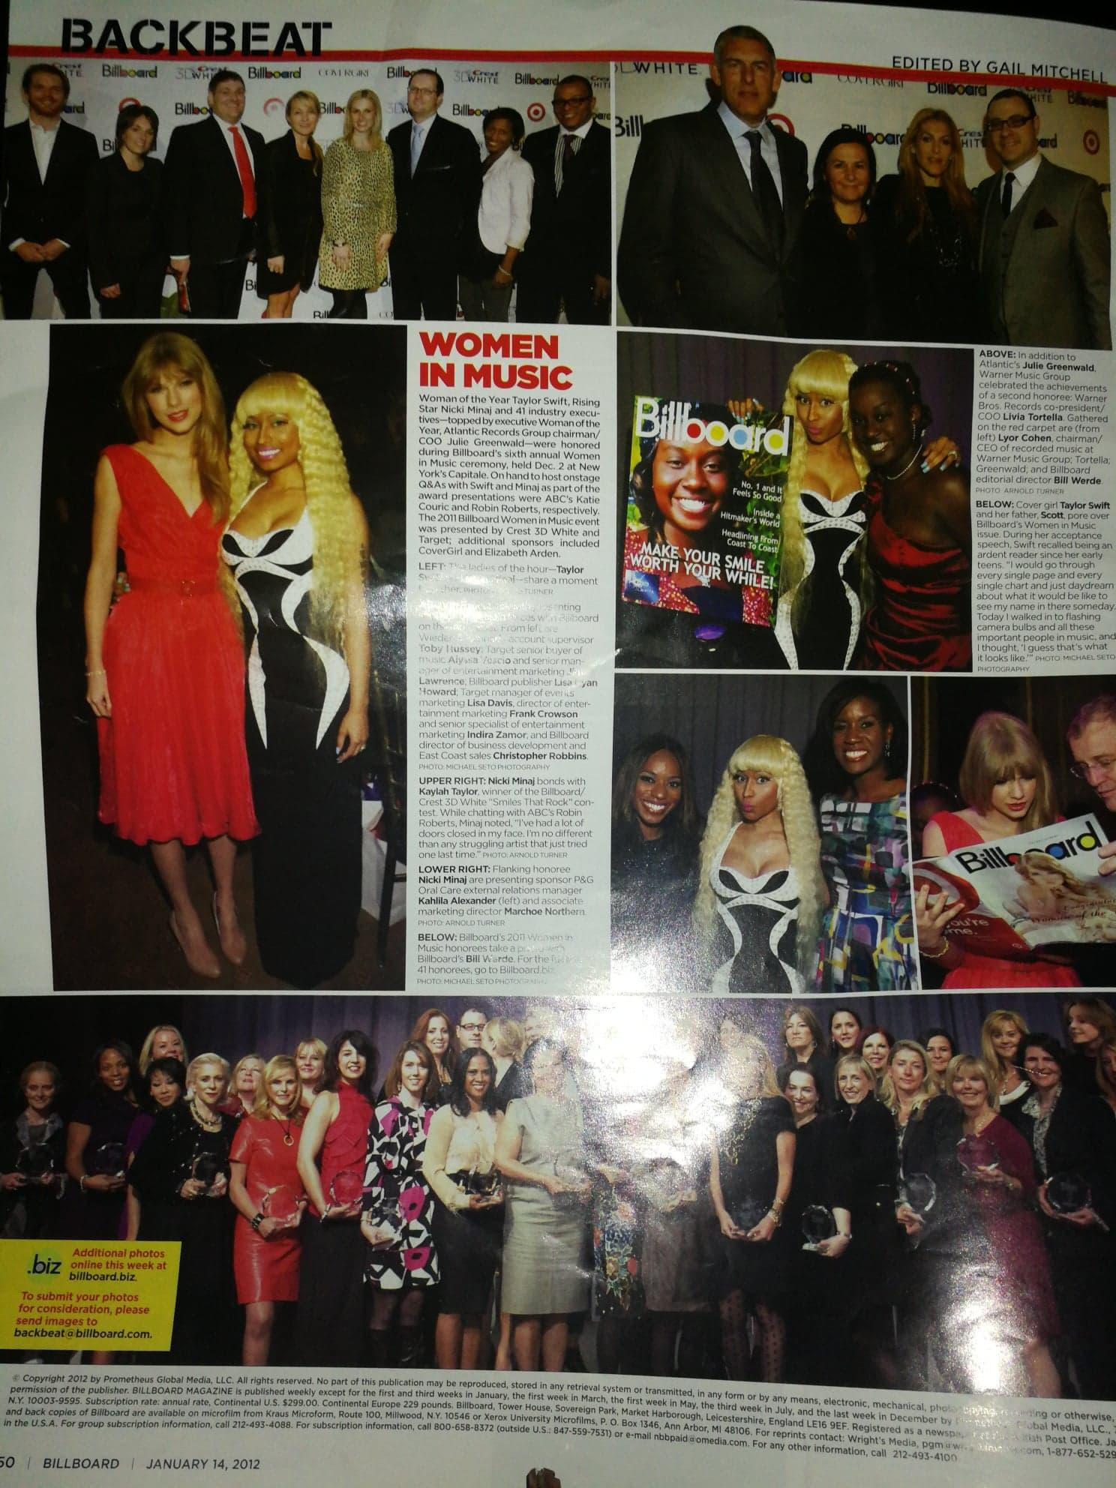
Billboard Music Magazine
January 14, 2012 Issue (LEFT)
With Nicki Minaj (Rapper)


6 Consecutive years since 2012 as featured soloist at the Fourth of July at the Biltmore Celebration (RIGHT ABOVE)
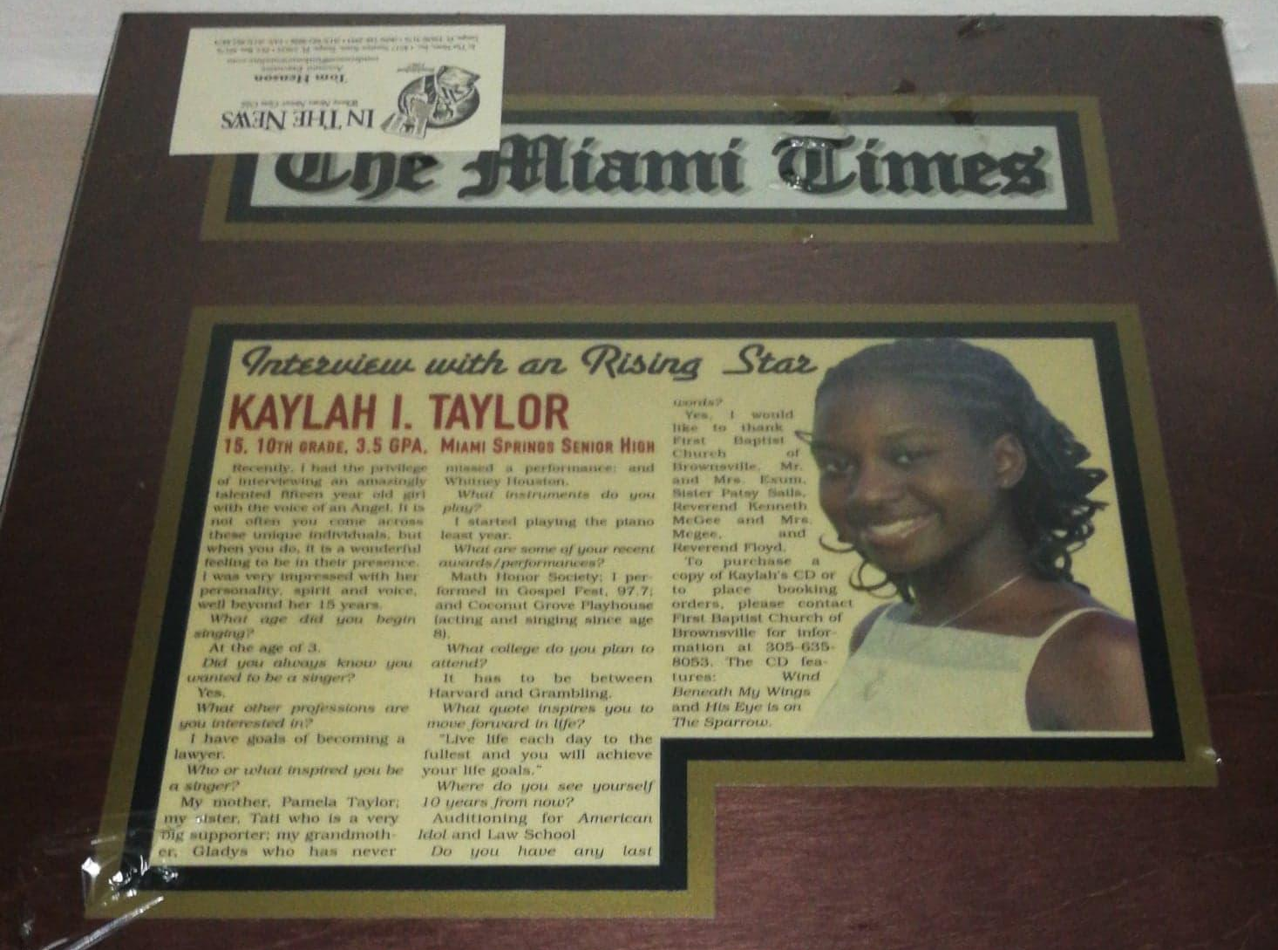
Featured Article in Miami Times Newspaper (2007)

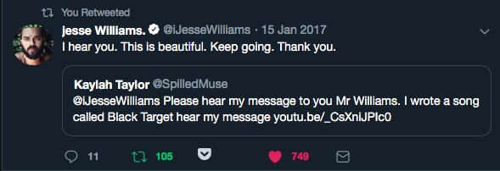
VIRAL TWEET: To Jesse Williams, actor on Grey’s Anatomy/Activist

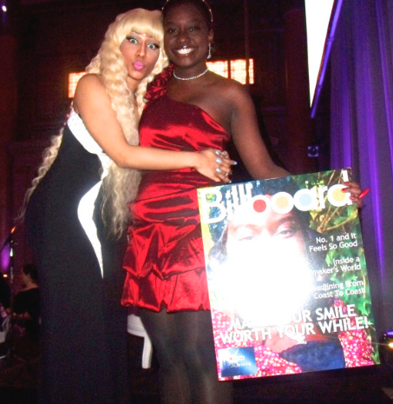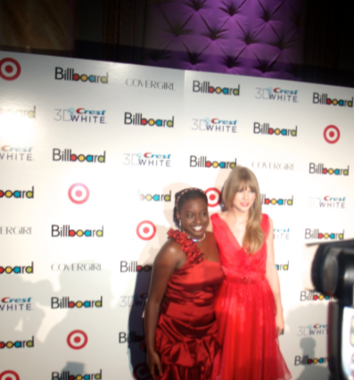
Nicki Minaj and Kaylah at Kaylah Taylor and Taylor Swift
Billboard Women in Music 2011 Billboard Women in Music 2011

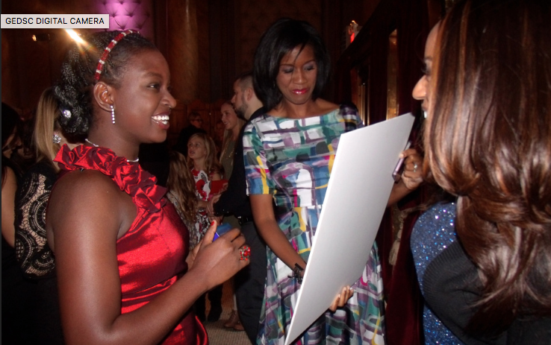
CREST 3D White Winner 2011
Kaylah Taylor

