Kaylah Taylor
“Her diligence to practice her craft and to expand her musicality is inspiring”
Professor Carol Anne Steele, Miami Dade College

“She has so much energy...she really got the crowd pumped. AMAZING JOB”
Anna Jiminez, Miami Realtors Association for Autism Awareness

“It is so well-written in terms of content but at the same time SO CATCHY!! It has been such a pleasure getting to be a part of your journey”
Professor Raina Murnak, University of Miami

“Kaylah, is a Smile that Rocks”
Crest 3D White, Billboard Women in Music, Billboard Magazine

Singer-Songwriter
Pianist
Guitarist
Educator
Composer
Producer

Kaylah Taylor
Singer-Songwriter, Pianist,
Guitarist, Educator, Composer, Producer

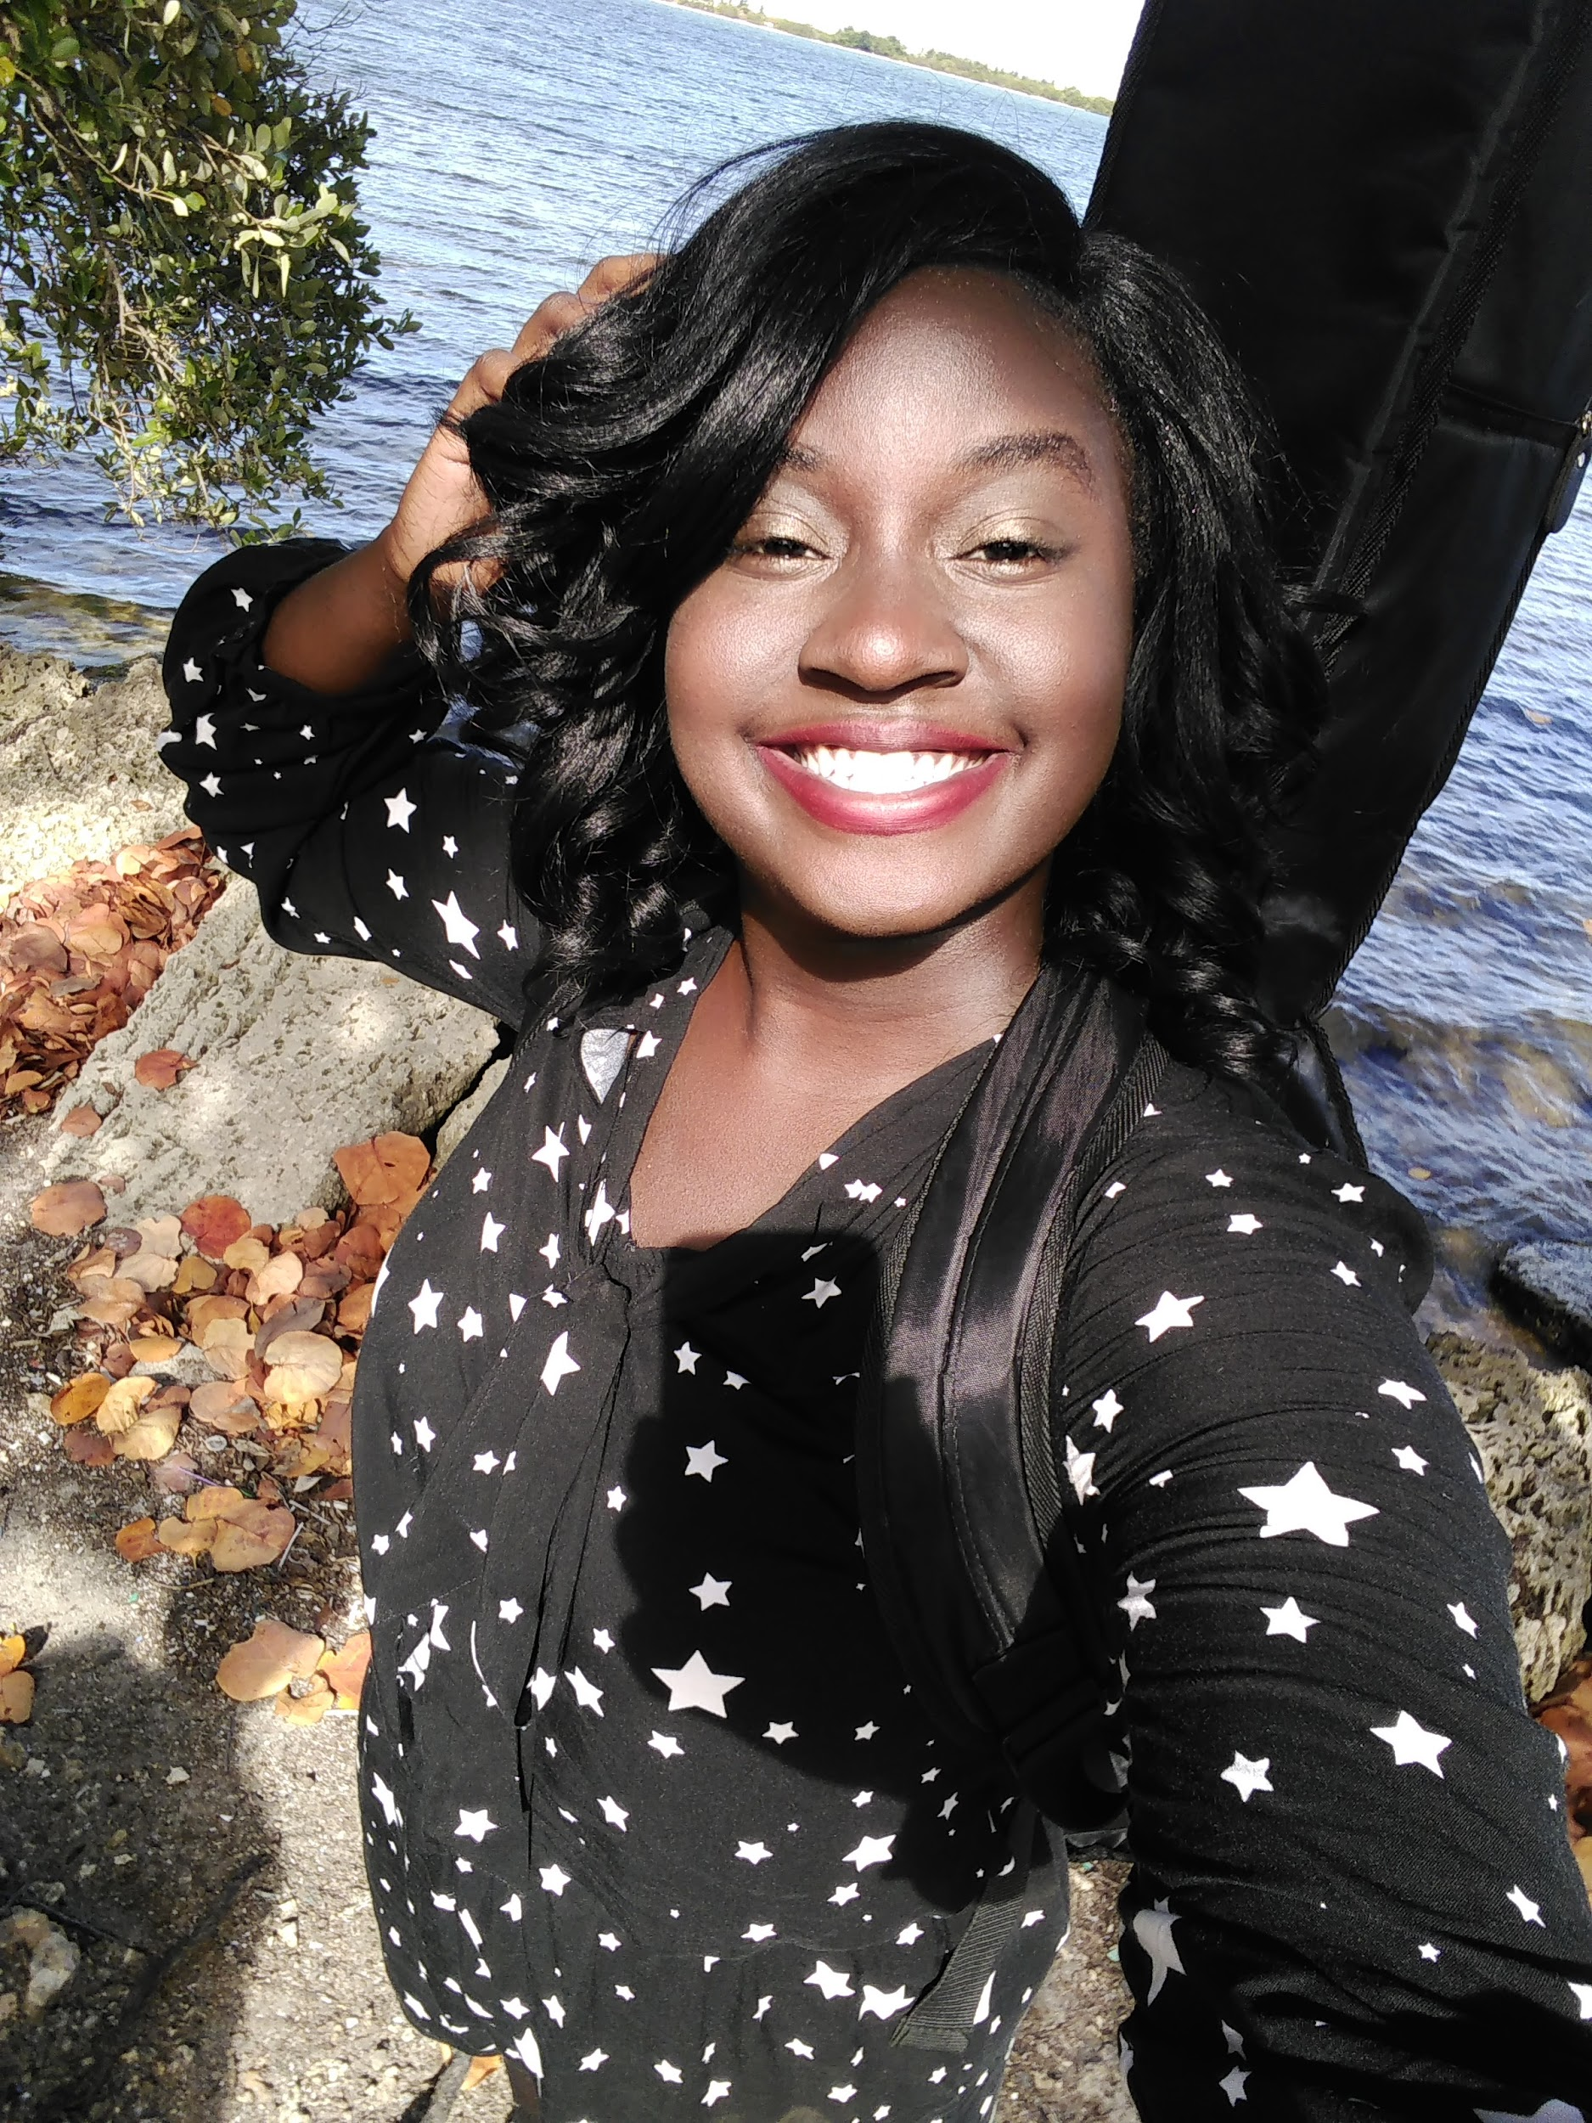
Kaylah Taylor is an energetic, focused, and driven musician that puts together every piece of herself to make her music. Kaylah is a singer-songwriter, pianist, guitarist, composer, and producer from Miami, FL. She is a graduate with her AA in Music from Miami Dade College. She continued to Florida International University to earn her B.A. in Music where she graduated; with honors, Cum Laude holding a 3.6 GPA. She studied opera throughout college and have sung in various languages. Kaylah says, “studying opera was difficult, however being open to learning it in college, added elements to my form and other styles of singing.”
When Kaylah was 13, her mom gift for her was to go into a recording studio for her birthday. Where she recorded a demo of her singing her favorite songs, it sparked a fire into Kaylah; because she started going to different social events around Miami singing, selling her demo and showcasing her talent. Kaylah has such a versatile taste in music that she says she can’t just say one artist of inspiration, its a plethora. Kaylah has also given private lessons in classical piano throughout her time in college. When in college she was a part of many ensembles from instrumental to the chorale. She was the jazz pianist and vocalist for the Falcon Jazz Band of Miami Dade North under the direction of Dr. Terri Mitchell. She also sang in the North Star Acapella Ensemble and Chamber Singers of Miami Dade North as well with Professor Carol Ann Steele as the Director. At Florida International University, she was a part of the Opera Studies program and the Vocal Jazz Ensemble under the direction of Dr. Lisa Anne Lyons. During her final semester at FIU, she was the Intern Coordinator at Miracle Mile, Actor Playhouse in Coral Gables; where she overseen the Young Talent Big Dreams competition held by the Children’s Trust of Miami. “The days I spent in my ensembles at college, were the best times it helped me develop my musicality,” Kaylah says.
Her works are versatile as a musician. Kaylah was once the Crest 3D Smile That Rocks winner; where she attended the Billboard Women in Music. She had a photo feature in the Billboards’ Music Magazine alongside rapper Nicki Minaj and walked the Red Carpet with Taylor Swift. Kaylah says, “It was a dream of a lifetime to be chosen and be a part of such a prominent event and to witness all the women in the industry in the room!”. She has sung the National Anthem, for the County Address for the Mayor Carlos Gimenez of Miami in 2013. For six consecutive years starting in 2012, she was the featured soloist for the “Fourth of July at the Biltmore Hotel” in Coral Gables with the Greater Miami Symphonic Band which has an attendance of up to 25,000 people. Kaylah has performed with Latin Grammy Winner Ed Calle alongside Jim Gasior and Nomar Negroni for a Tribute concert to songs of Burt Bacharach in 2012; where she was the vocalist. She has always seen throughout her time to help other young aspiring musicians. She has been a judge for the NAACP ACT-SO Competition since 2012; as well as their traveling accompanist on the piano to national competitions. NAACP ACT-SO is a national competition for high school and middle school that gives youth the chance to showcase their talents in different art forms. She also has done many events for Autism Awareness including being the featured performer for the opening of the Autism Sensory Friendly Garden in Pinecrest Gardens in March 2019.
One of Kaylah’s favorite things to do is write music. She says, “When I write music it is an escape for me and allows me to imagine and communicate to others.” Kaylah has made many songs. In 2016 she released an Album called “Black Target” where she recorded and produced the entire project. Her latest album released in 2018 is called “Autism Speaks.” Kaylah wrote "Autism Speaks" and feels that she could use her music to spread awareness; she is also on the autism spectrum. She recorded and produced two versions of the song a Pop Version and a Sensory Friendly Version (Acoustic) which is a calm and soothing, piano version of the song.
Kaylah skills as a producer of her music are something to be admired. She is intensely focused. When she starts a song she finishes it. She writes the lyrics, music, records, and masters her works. She is also a part of ASCAP, NAACP, and is currently a teacher in the subject of music...of course! Kaylah is currently pursuing her Masters in Music Business and Entertainment Industries at the University of Miami.

Hot off the Press!

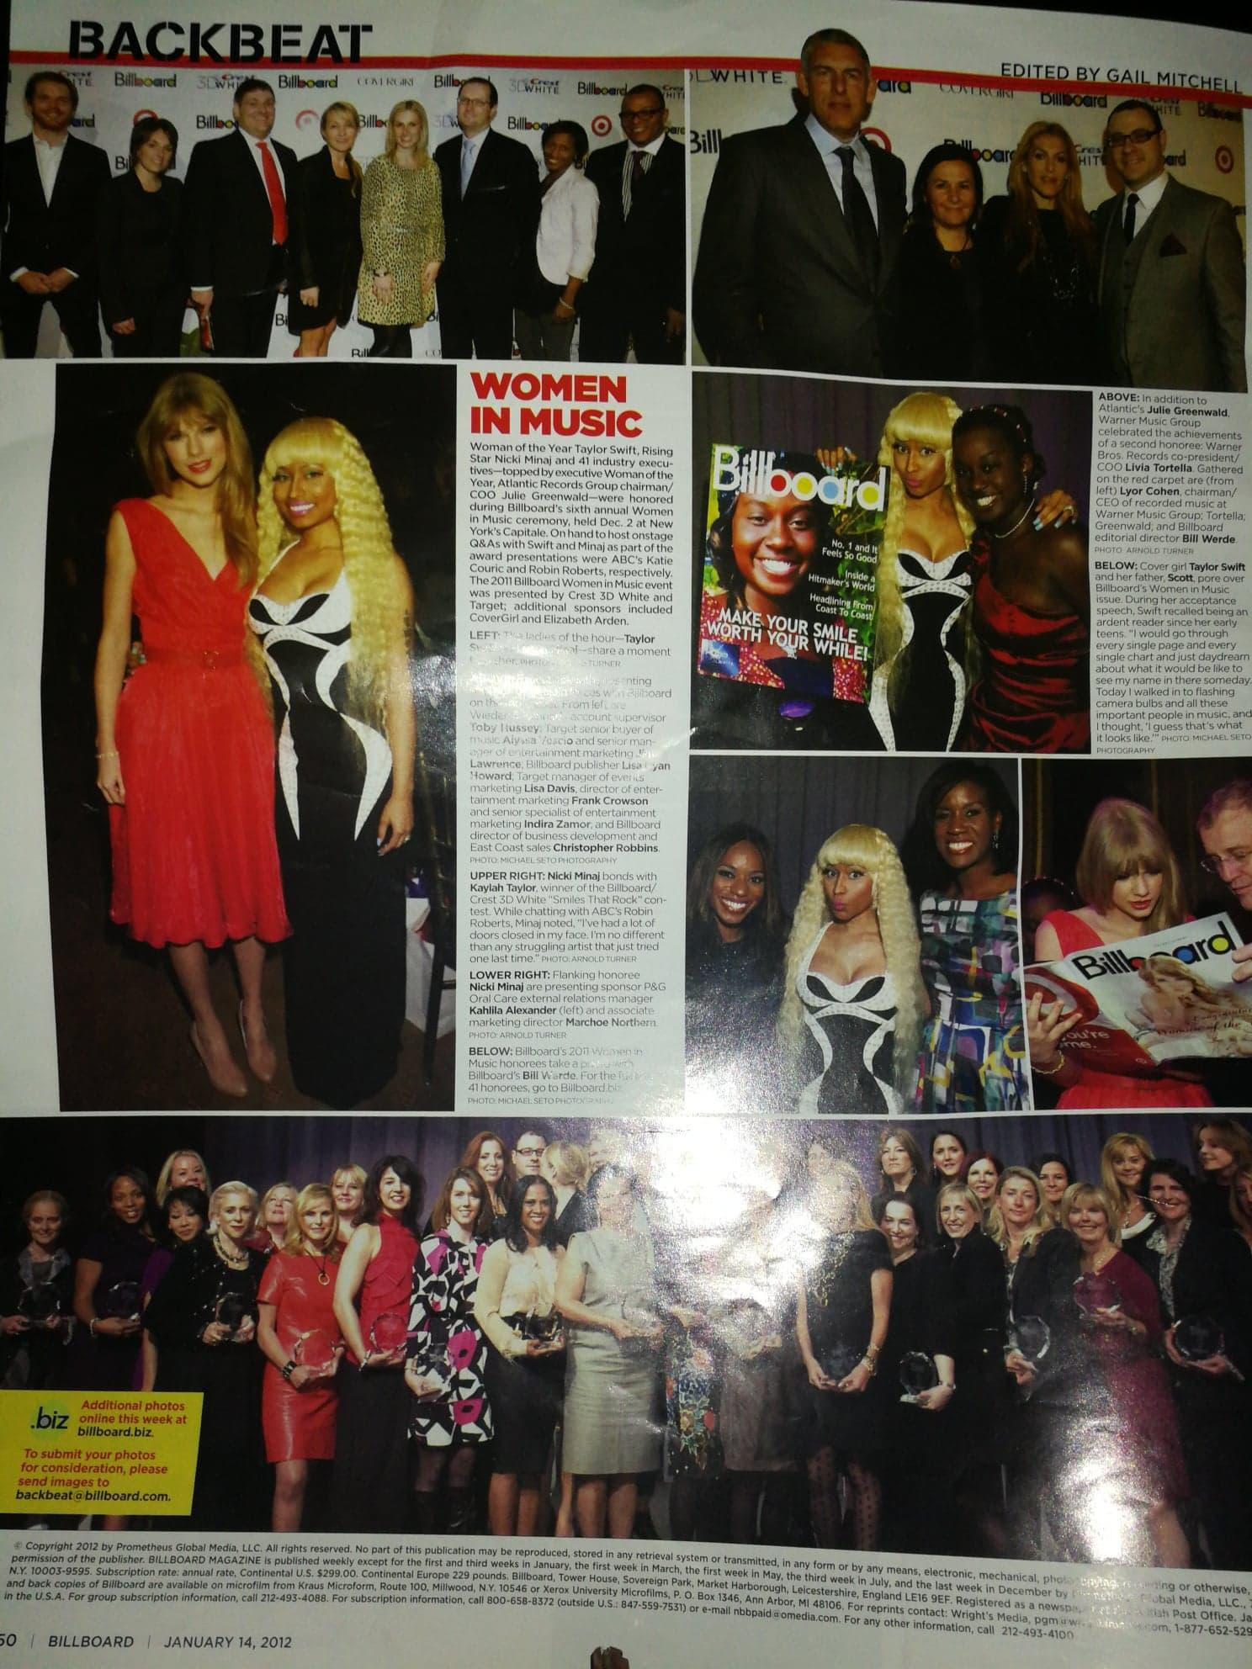
Billboard Music Magazine
January 14, 2012 Issue (LEFT)
With Nicki Minaj (Rapper)
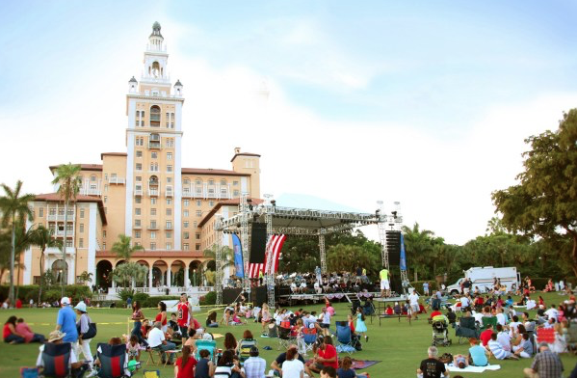

6 Consecutive years since 2012 as featured soloist at the Fourth of July at the Biltmore Celebration (RIGHT ABOVE)
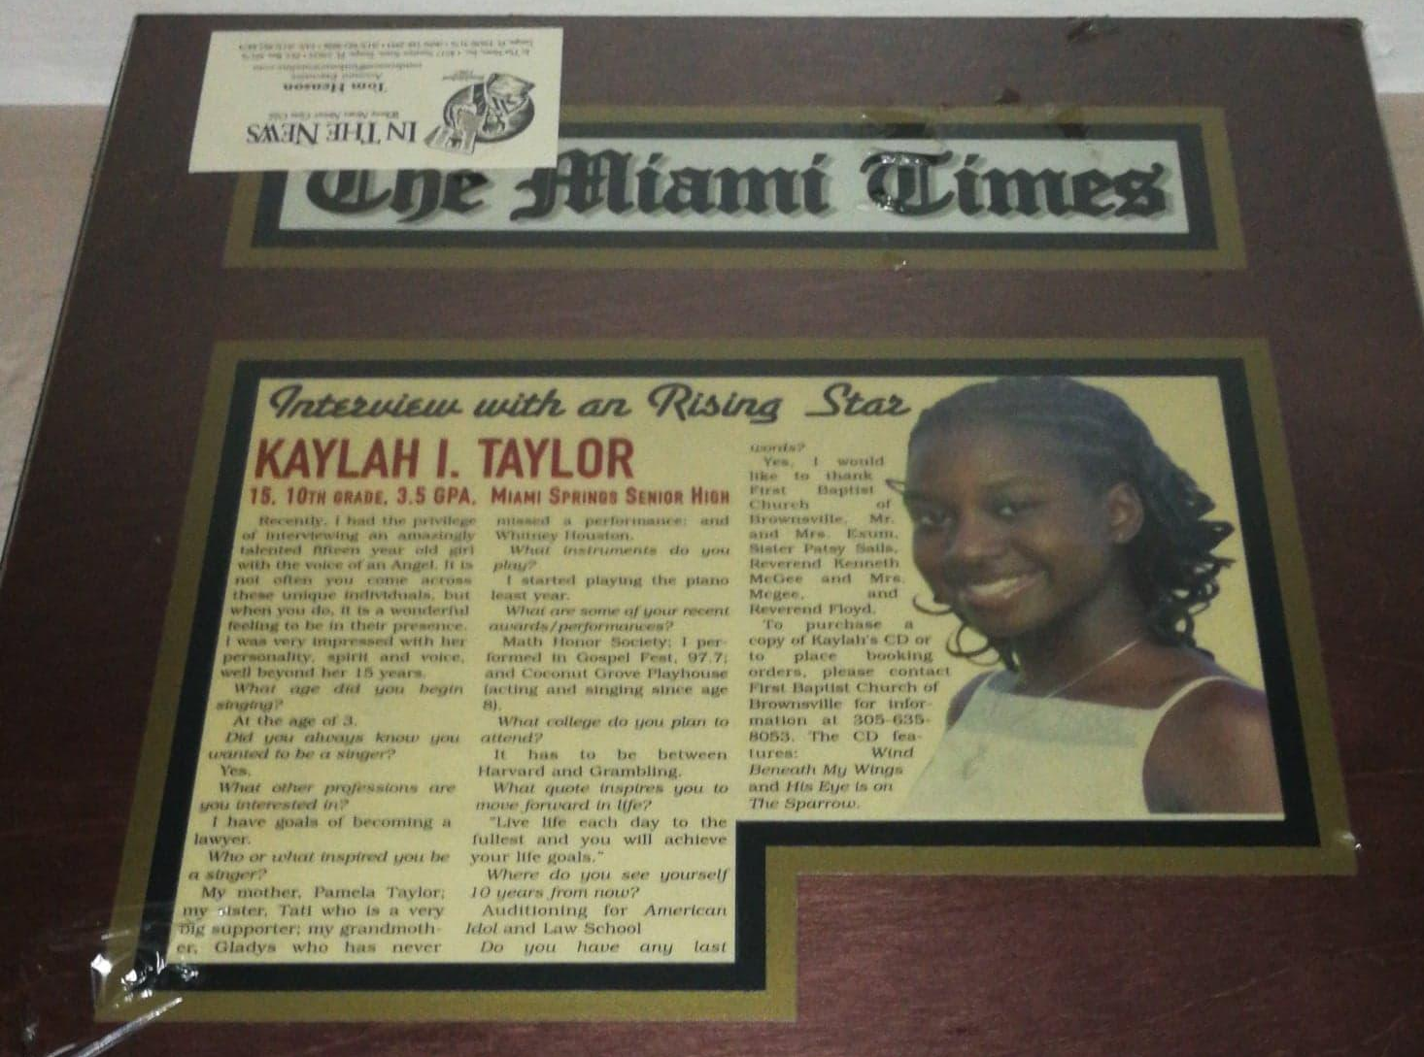
Featured Article in Miami Times Newspaper (2007)

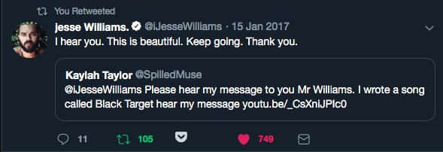
VIRAL TWEET: To Jesse Williams, actor on Grey’s Anatomy/Activist

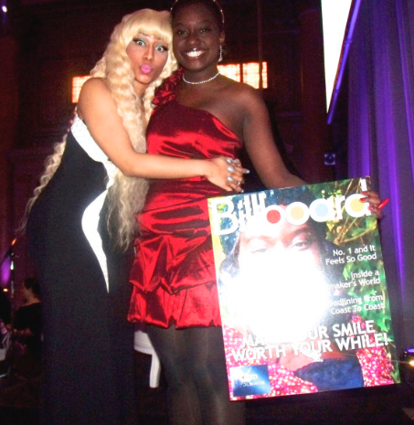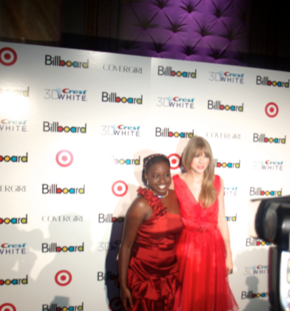
Nicki Minaj and Kaylah at Kaylah Taylor and Taylor Swift
Billboard Women in Music 2011 Billboard Women in Music 2011

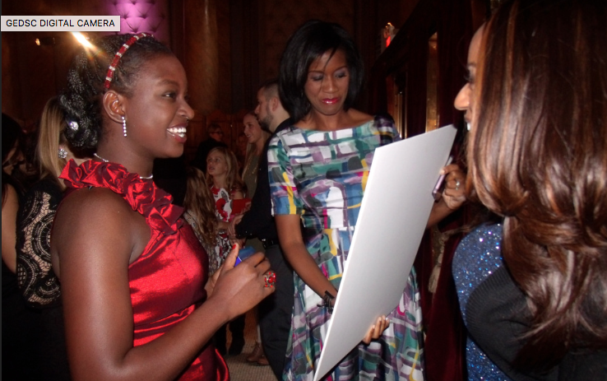
CREST 3D White Winner 2011
Kaylah Taylor

KAYLAH TAYLOR HIGHLIGHT VIDEO: https://youtu.be/dlwcTtKVaQY

KAYLAH TAYLOR EAST OF THE SUN: https://youtu.be/yPC0MyvblfQ

Kaylah Taylor Discography

Autism Speaks Recorded March 2018, released 2018. Lyrics, Music, Piano, Drums, Guitar, Synth, Recorded and Master by Kaylah Taylor © 2018 ASCAP

Black Target Recorded July 2016, released 2016. Lyrics, Music, Guitar, Piano, Drums, Recorded and Mastered by Kaylah Taylor © 2016 ASCAP

Kaylah’s Projects and Ensembles

Promoting Awareness through Music
Kaylah has made songs promoting issues about social awareness. With her album like Black Target and Autism Speaks. She is finding ways to go around to events and promote her music consistently. She loves to perform and is actively doing so present day.

Educator
Kaylah is an educator at Downtown Miami Charter School, where she is the music teacher. She has 658 students from grades K-6. She teaches drama as well to the 6th graders who just won 2-1st places, 1-2nd Place and 1-3rd Place at the Miami Dade County Fair Theater Competition.

Actively Performs at Local Venues and Out of Area
Kaylah really loves to perform and brings so much energy to the stage. She is a singer, pianist, guitarist and knows how to produce her own music.
CONTACT

Artist Website: https://kaylahtaylor.com

Facebook Page: https://www.facebook.com/KaylahTaylorMusic/

Email: itskaylahtaylor@yahoo.com

SOCIAL MEDIA

Instagram: https://www.instagram.com/musiclaughfun/

Youtube: https://www.youtube.com/user/miamikaytay

SoundCloud: https://soundcloud.com/kaylah-taylor

Music Available on iTunes, Google Play Amazon

Search: Kaylah Taylor

